Moore Machine Based Calculator
Theory Of Automata Project
Group Members:
Muhammad Maaz 23FA-013-CS
Taha Nadeem 23FA-003-CS
Course Instructor: Sir Jawwad Bhutta
Course: Theory Of Automata
Semester: V CS-A

Introduction
This project is a GUI-based calculator implemented using the concept of a Moore Machine. The main motivation behind this project was to solve a common problem which is seen in simple calculators: they keep calculating continuously even when users enter expressions that do not follow proper order or structure, which can mislead non-technical or layman users.
To overcome this issue, the calculator is intentionally designed to accept only two operands and one operator at a time. After computing the result, the user can continue calculating by using the result as the first operand again. This design makes the calculator predictable, controlled, and easier to understand.
2. Problem Statement
Many simple calculators evaluate expressions sequentially without enforcing proper structure or order of operations, which can result in misleading outputs. This becomes confusing for non-technical users who may assume correct mathematical evaluation. There is a need for a controlled calculator that enforces valid input structure and avoids misleading results.
3. Objective of the Project
The objectives of this project are:
- To demonstrate the practical implementation of a Moore Machine
- To restrict calculator input to avoid misleading calculations
- To show how finite states control valid and invalid expressions
- To provide a visual representation of state transitions using a GUI

4. Theory Background
4.1 Finite State Machine
A finite state machine consists of a finite number of states, transitions, inputs, and outputs. It processes input symbols and changes states based on transition rules.
4.2 Moore Machine
A Moore Machine is a type of finite state machine where the output depends only on the current state, not on the input. Each state produces a fixed output, making the system predictable and easy to model.
5. System Design
5.1 States Description
The calculator is designed using the following states:
- q0 – Start state
- q1 – First operand state
- q2 – Operator state
- q3 – Second operand state
- q_result – Result state
- qt – Trap (error) state
5.2 Input Alphabet
- Digits: 0–9
- Operators: + , − , × , ÷
- Special symbols: = , C

5.3 Output Alphabet
- Digits displayed on screen
- Operators displayed
- Computed result
- Error message for invalid expressions

6. Working of the Calculator
The calculator works by transitioning between states based on user input:
- q0 accepts the first digit
- q1 builds the first operand
- q2 accepts the operator
- q3 builds the second operand
- q_result computes and displays the result
- qt handles all invalid expressions
Only valid input sequences allow progression to the result state.

7. Error Handling Mechanism
A single trap state (qt) is used to handle all invalid inputs such as:
- Operator entered first
- Incomplete expressions (e.g., 2+)
- Extra input beyond allowed structure
A single trap state is used to keep the Moore Machine finite and simple.

8. Technology Stack
- Programming Language: Python
- GUI Framework: Tkinter
- Concept Used: Moore Machine (Theory of Automata)

9. Graphical User Interface (GUI)
The GUI consists of:
- A display area for input and result
- Buttons for digits, operators, equals, and clear
- A state label that shows the current Moore Machine state
This helps users visually understand how state transitions occur.

10. Moore Machine Diagram
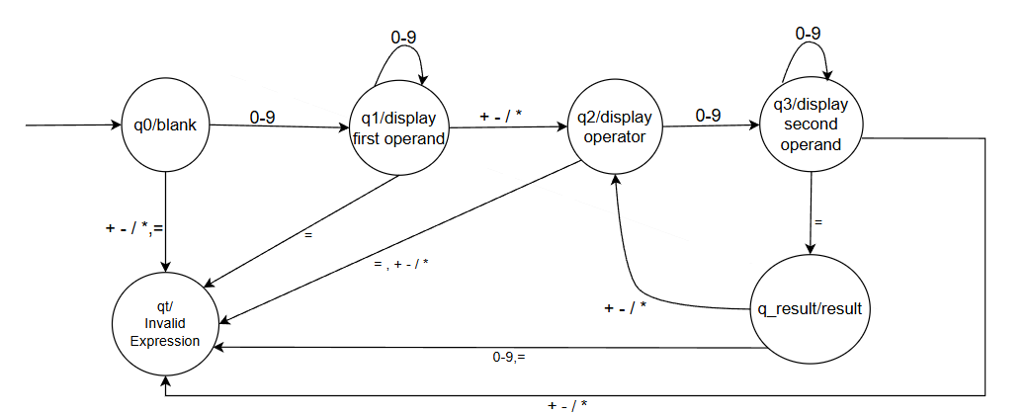

Future Improvements:
Add acceptance of negative integers
Add decimal numbers support
Add scientific calculator features
11. Conclusion
This project demonstrates the practical application of a Moore Machine using a calculator. By limiting the calculator to two operands at a time, misleading sequential calculations are avoided. The system remains finite, predictable, and easy to explain, making it suitable for academic demonstration.

